|  |  |  |  |  |
| --- | --- | --- | --- | --- |
| **WEEK** | **VALUE PROMISE** | **MEMORY VERSE** | **CHARACTER TRAITS** | **WORK HABIT** |
| **TWO** | “ I believe in only one God as my God ”. | Matthew 25:35 | 1. Be caring  2. Be responsible  3. Be hospitable  4. Be receptive  5. Have individual responsibility | Do not settle for anything less than excellence |

Matthew 25:35 “For I was hungry and you gave me food I was thirsty and you gave me a drink, I was a stranger, and you invited me in”.

Work habit

Name: \_\_\_\_\_\_\_\_\_\_\_\_\_\_\_\_\_\_\_\_\_\_\_\_\_\_\_\_\_\_\_\_\_\_\_\_\_\_\_\_\_

Date: \_\_\_\_\_\_\_\_\_\_\_\_\_\_\_\_\_\_\_\_\_\_\_\_\_\_\_\_\_\_\_\_\_\_\_\_\_\_\_\_\_\_

School: \_\_\_\_\_\_\_\_\_\_\_\_\_\_\_\_\_\_\_\_\_\_\_\_\_\_\_\_\_\_\_\_\_\_\_\_\_\_\_\_\_

Spellings Corrections

1. 1.

2. 2.

3. 3.

4. 4.

5. 5.

**THEME:** OUR SCHOOL AND NEIGHBOURHOOD.

**SUBTHEME:** Location, symbols and benefits of our school.

School- is the place where people go to learn.

Location of our school

I am Samuel and she is Ruth. We go to Carson School. A school is a place where pupils go to learn. Carson School is located in Wakiso district, in Kiteezi.

There is a signpost near our school. There are important places near our school.

There are important places near our school

like garages, shops, hotels, church, mosque, police station and many others.

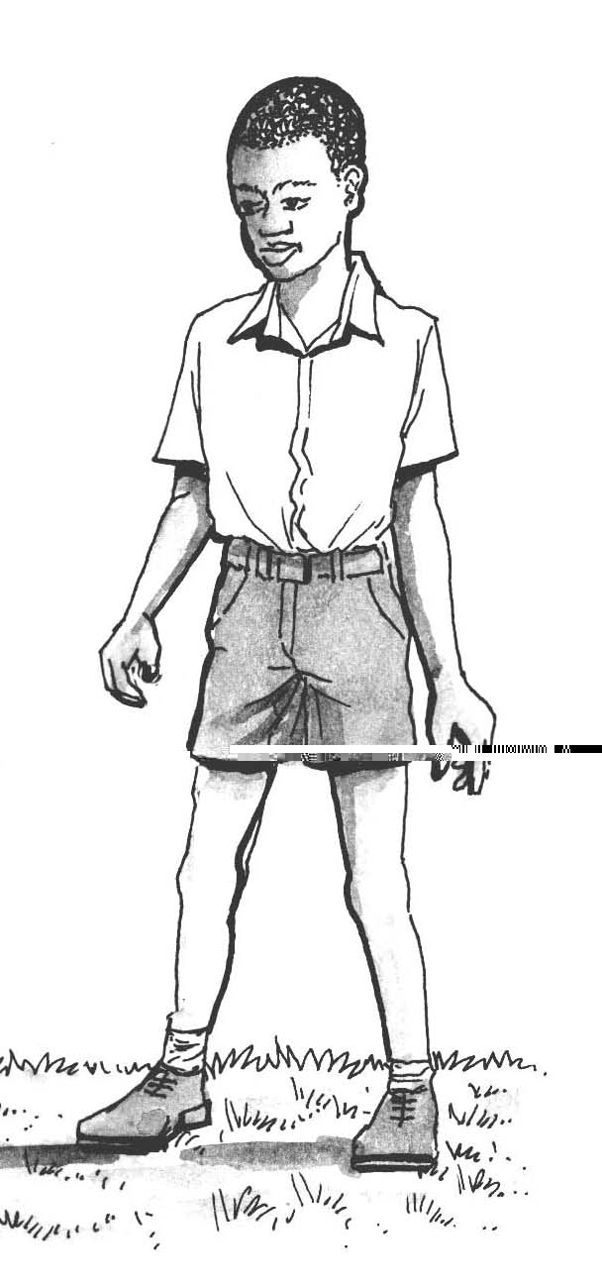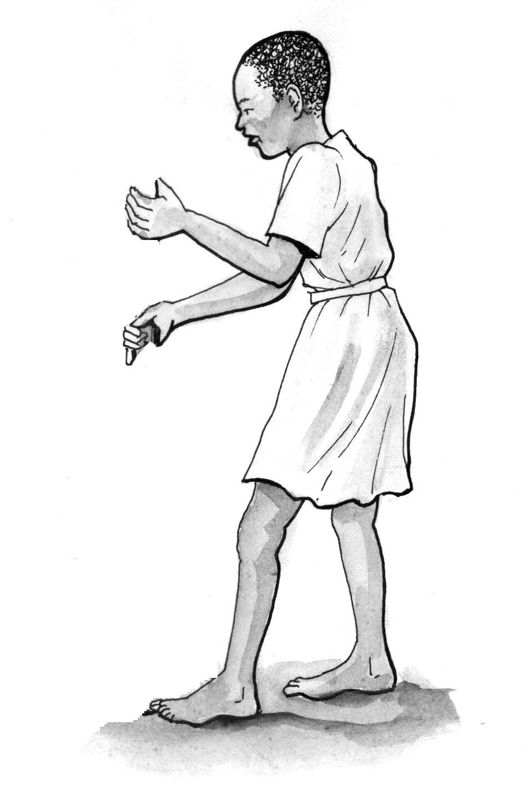

**Activity**

1. What is the name of your school?

2. Our school is found in along

road.

3. What is a school?

4. In which district is your school found?

5. Our school is found in division / sub-county.

6. Name four important places near our school.

7. Our school and neighborhood.

a) There is a and a

in front of Carson School.

b) There is a behind Carson School.

c) Name any four important places near Carson School.

d) How flags are at Carson School?

e) There are trees around Carson School.

Corrections

***Score strip***

Name: \_\_\_\_\_\_\_\_\_\_\_\_\_\_\_\_\_\_\_\_\_\_\_\_\_\_\_\_\_\_\_\_\_\_\_\_\_\_\_\_\_

Date: \_\_\_\_\_\_\_\_\_\_\_\_\_\_\_\_\_\_\_\_\_\_\_\_\_\_\_\_\_\_\_\_\_\_\_\_\_\_\_\_\_\_

Spellings Corrections

1. 1.

2. 2.

3. 3.

4. 4.

5. 5.

**School symbols.**

School symbols are things which make a school different from other schools.

**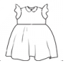Examples of school symbols are;**

CARSON SCHOOL

****

School uniform school flag school badge school signpost

|  |  |  |
| --- | --- | --- |
| School prayer | School motto | School mission |
|  | Together we achieve more |  |

**Importance of a school**

- It helps children to behave well.

- It protects children from danger.

- It helps children to learn.

**Important places near our school**

- church - market - hotel - hospital

- school - mosque - police station.

Activity

1. Write down five symbols of our school.

2. Write the colour of your school uniform.

3. What are school symbols?

4. Draw these school symbols.

|  |  |  |
| --- | --- | --- |
| school uniform | school flag | school signpost |
|  |  |  |

5. Why do we need to have school symbols?

6. Write the school motto.

7. How is the school prayer useful?

8. Draw your school badge.

9. What is the special song of your school called?

10. What is the use of a school sign post?

Corrections

***Score strip***

Name: \_\_\_\_\_\_\_\_\_\_\_\_\_\_\_\_\_\_\_\_\_\_\_\_\_\_\_\_\_\_\_\_\_\_\_\_\_\_\_\_\_

Date: \_\_\_\_\_\_\_\_\_\_\_\_\_\_\_\_\_\_\_\_\_\_\_\_\_\_\_\_\_\_\_\_\_\_\_\_\_\_\_\_\_\_

Spellings Corrections

1. 1.

2. 2.

3. 3.

4. 4.

5. 5.

**Things found in each school symbol.**

**Flag;**

- Name of the school.

- School motto.

**Signpost;**

- Name of the school.

- Badge of the school.

- Arrow showing the location of the school.

- Address of the school.

- P.O box of the school.

**School uniform**

- Badge

- School name

**Badge**

- Name of the school.

- School motto.

- School emblem.

**Importance of each school symbol**

i) The school name: Shows the name of the school and identity

ii) The school uniforms: Makes pupils look smart

Makes children different from other

pupils.

iii) The school prayer: Teaches us to fear God

iv) The school motto: Encourages pupils to work harder

v) The school signpost: Shows the location of the school

vi) The school badge: Helps people to know the name of the

school and motto

vii) The school anthem: Teaches us to show respect

**Activity**

1. makes the pupil look smart.

2. Write the things found on;

a) School badge.

i)

ii)

b) School sign post

i)

ii)

c) School flag

i)

ii)

3. Mention two things that help to locate our school.

i)

ii)

4. What is the special song of your school called?

More practice (corrections)

***Score strip***

****

Checkup 1

Supervisor’s initial \_\_\_\_\_\_\_\_\_\_\_\_

Score \_\_\_\_\_\_\_\_\_\_\_\_

Supervisor’s comment \_\_\_\_\_\_\_\_\_\_\_\_\_\_\_\_\_\_\_\_\_\_\_\_

**PROJECT WORK**

Think of your own school. Using box cutouts make a badge, sign post, motto, and flag. Make your work well coloured to make it look attractive.

|  |  |  |  |  |
| --- | --- | --- | --- | --- |
| **WEEK** | **VALUE PROMISE** | **MEMORY VERSE** | **CHARACTER TRAITS** | **WORK HABIT** |
| **THREE** | “I will always be true and do the right things”. | 1st Timothy 4:12 | 1. Be of great integrity & dignity  2. Be truthful  3. Be genuine  4. Endurance & honesty  5. Be bold | Be gentle to all and stern to all |

1st Timothy 4:12 “Do not let anyone look down on you because you are young, but be an example for the believers in your speech your conduct, your love, faith and purity”.

Work habit

Name: \_\_\_\_\_\_\_\_\_\_\_\_\_\_\_\_\_\_\_\_\_\_\_\_\_\_\_\_\_\_\_\_\_\_\_\_\_\_\_\_\_

Date: \_\_\_\_\_\_\_\_\_\_\_\_\_\_\_\_\_\_\_\_\_\_\_\_\_\_\_\_\_\_\_\_\_\_\_\_\_\_\_\_\_\_

School: \_\_\_\_\_\_\_\_\_\_\_\_\_\_\_\_\_\_\_\_\_\_\_\_\_\_\_\_\_\_\_\_\_\_\_\_\_\_\_\_\_

Spellings Corrections

1. 1.

2. 2.

3. 3.

4. 4.

5. 5.

**SCHOOL STRUCTURES**

School structures are buildings found in the school.

**Examples of school structures**

1. **Classroom**

Pupils sit and learn from the classroom

1. **Toilet/latrine**

Pupils ease themselves from toilets/latrines

1. **Kitchen**

Food at school is prepared from the kitchen

1. **Office**

Head teacher, bursar and secretaries do their work from the office

1. **Sickbay**

Sick pupils are cared for in the sickbay.

1. **Staffroom**

Teachers meet and rest from the staffroom.

1. **Dormitory**

Boarder pupils sleep in the dormitory.

1. **Library**

Textbooks and readers are kept in the dormitory.

1. **School canteen**

We buy things from the school canteen

1. **Store**

The school property is kept in the store.

**Materials used to build.**

Examples of building materials a school gets from its neighbours.



sand stones poles

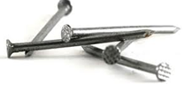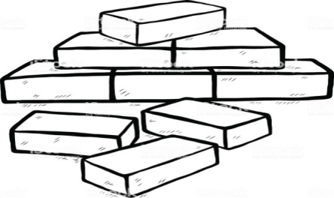

bricks nails iron sheets

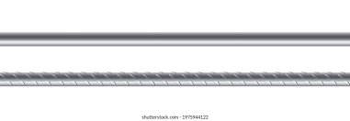

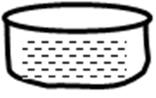

iron bars cement water

**Types of houses**

a) Temporary houses are houses which do not last for a long time.

**Examples of temporary houses**

- Unipot - tent

- hut - mud house

b) P**ermanent houses** are houses which last for a long time.

**Examples of permanent houses**

- Bungalow

- Flat/ storied building.

**Activity**

1. Match the following.

|  |  |
| --- | --- |
| library | where we go to ease ourselves |
| kitchen | where pupils go for treatment |
| toilet/ latrines | where food is prepared |
| sickbay | where school books are kept |
| classrooms | where pupils learn from |
| store | where school property is kept |

2. How important are the following structures?

Dining halls

Library

Toilets

Kitchen

Classrooms

**3. Draw these building materials.**

|  |  |  |  |
| --- | --- | --- | --- |
| nails | iron sheets | bricks | cement |
|  |  |  |  |

4. A person who builds structures at school is a

(teacher, builder, carpenter)

6. Define the following terms;

a) Permanent house.

b) Temporary house.

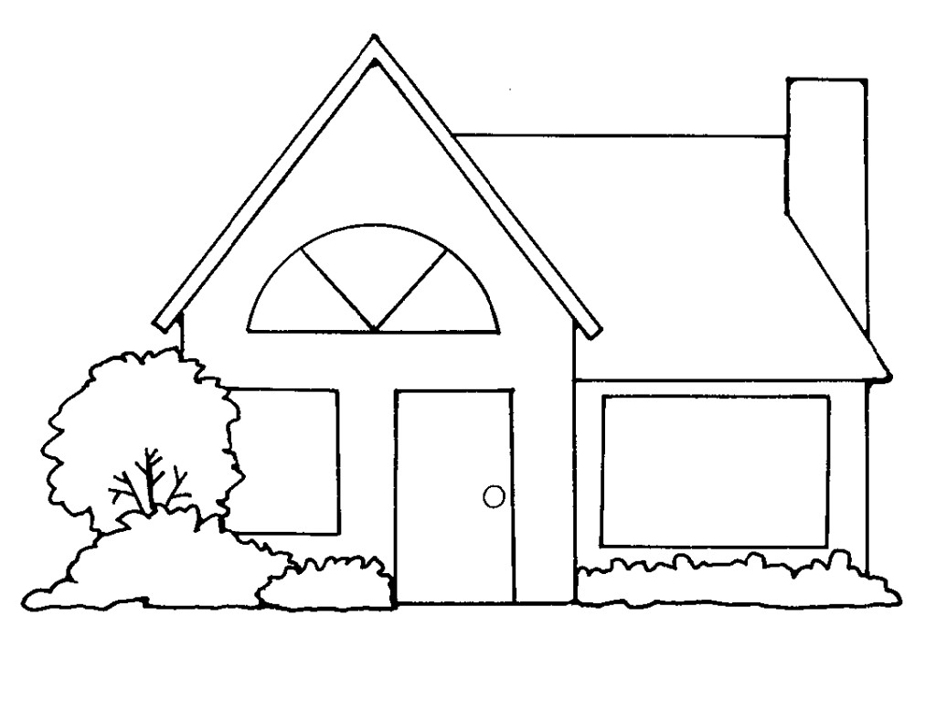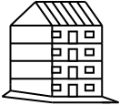 7. Name these examples of houses.

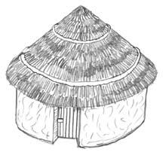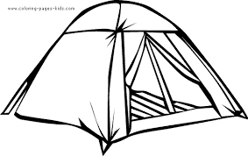

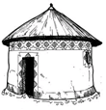

More practice (corrections)

***Score strip***

Name: \_\_\_\_\_\_\_\_\_\_\_\_\_\_\_\_\_\_\_\_\_\_\_\_\_\_\_\_\_\_\_\_\_\_\_\_\_\_\_\_\_

Date: \_\_\_\_\_\_\_\_\_\_\_\_\_\_\_\_\_\_\_\_\_\_\_\_\_\_\_\_\_\_\_\_\_\_\_\_\_\_\_\_\_\_

Spellings Corrections

1. 1.

2. 2.

3. 3.

4. 4.

5. 5.

**People in our school**

**People found at school.**

\* School administrator- is a person who organizes the business of an institution.

\* Director- is a senior manager who runs the school.

\* Head teacher- is a teacher who is in charge of a school.

\* Deputy head teacher- is the person who is next to the head teacher.

\* Teacher- is a person whose job is teaching in a school.

\* Senior woman- is a woman who counsels girl s in a school.

\* Bursar- is a person who manages the financial affairs of a school.

\* A matron- is a woman who cares for children at school.

\* School driver- drives the school car.

\* Security guard- guards the school valuables or building.

\* Gate keeper- is a person who checks and controls the gate.

\* Cleaner- cleans the school compound.

\* Cook- cooks food at school.

\* Prefects- guides and controls the school activities.

**Activity**

1. Name these people found at school.

|  |  |
| --- | --- |
| ANd9GcSSFOgBz_xo6Vh8Q4Ea-BEaXOzSz75NEye5gmcbgYuueB__qcDm | ANd9GcRZsU1Wja90uYz6VOvM2LADVSPVJi-ICM2WrxLwSeo0g_ocTE-ggA |
|  |  |

|  |  |
| --- | --- |
| ANd9GcQWPa5kAR4XwHJsuDJ8ra0WGLgAefnGCGVJXgh2UMCEIT2LMkGH | http://i.istockimg.com/file_thumbview_approve/43734226/6/stock-illustration-43734226-whiteboard-drawing-smiling-kids-standing.jpg |
|  |  |

2. Write the name of your head teacher at school.

3. Why do we need teachers at school?

4. Who is your best friend at school?

5. Who keeps the school clean?

**6. Match the following people to their roles.**

|  |  |
| --- | --- |
| Bursar | cares for children at school |
| Teacher | collects money at school |
| Cook | teaches children |
| Matron | cooks food |
| Deputy head teacher | helps the head teacher |

7. Write material used by the following people Children at school

a)

b)

c)

Cook

a)

b)

c)

Security guards

a)

b)

c)

More practice (corrections)

***Score strip***

Name: \_\_\_\_\_\_\_\_\_\_\_\_\_\_\_\_\_\_\_\_\_\_\_\_\_\_\_\_\_\_\_\_\_\_\_\_\_\_\_\_\_

Date: \_\_\_\_\_\_\_\_\_\_\_\_\_\_\_\_\_\_\_\_\_\_\_\_\_\_\_\_\_\_\_\_\_\_\_\_\_\_\_\_\_\_

Spellings Corrections

1. 1.

2. 2.

3. 3.

4. 4.

5. 5.

Activity

1. State any two responsibilities of children at school.

i)

ii)

2. What is P.O BOX in full?

3. How important is a school to children?

4. What is the role of these people in a school?

Prefects

Classmates

Head teacher

Secretary

5. Draw the Uganda flag and its 3 colours.

6. What does the yellow colour mean?

7. According to the Ugandan flag, what does the red colour mean?

8. How many colours has the Uganda flag?

9. Which bird is found in the middle of the Uganda flag?

More practice (corrections)

***Score strip***

Name: \_\_\_\_\_\_\_\_\_\_\_\_\_\_\_\_\_\_\_\_\_\_\_\_\_\_\_\_\_\_\_\_\_\_\_\_\_\_\_\_\_

Date: \_\_\_\_\_\_\_\_\_\_\_\_\_\_\_\_\_\_\_\_\_\_\_\_\_\_\_\_\_\_\_\_\_\_\_\_\_\_\_\_\_\_

Spellings Corrections

1. 1.

2. 2.

3. 3.

4. 4.

5. 5.

**Class rules and school rules**

**Rules;**

**Class rules;** are rules that govern the class.

Examples;

- Making noise in class is not good.

- Always welcome visitors.

- Playing in class is bad.

- Love one another.

- Use magic words at all times.

**School rules;** are rules that govern the school.

Examples;

- Move out of the school with permission.

- Always be smart.

- Always respect your teachers.

- Be good time managers.

**Time table**

Things found on the time table.

Time, name of the class, days of the week, subject.

Importance of time table

- Time table shows the right time for each activity

- It shows what to do

- It represents the program of the day.

**Needs at school**

**School needs** – are things that a school cannot be without.

Examples;

Foods, water, furniture, play materials, scholastic materials and medical care.

**Ways in which the school meets its needs;**

- Some schools have projects.

- Some schools have sponsors.

- Some parents give the school money by paying school fees.

**Problems which a school faces when meeting its needs**

- Some parents do not pay school fees.

- Some people steal the school properties.

- Animals destroy the crops on the school garden.

- Sunshine dries up the crops at the school garden.

**Ways of solving school problem**

- School property should be kept safely.

- Broken furniture should be repaired.

**Neighbour**

A **neighbour** is a person near you.

Benefits of the neighbourhood to the school

Food, friends, land, water, materials, firewood, labour, security and buildings

**Benefits of the school to the neighborhood**

* The school teaches children from the neighbourhood
* The school gives jobs to the people
* The school is a meeting place for the people for the people from the neighbourhood
* The school teaches good behaviors e.g. cleanliness
* The school lends furniture to the people in the neighbourhood
* The school entertains people in the neighbourhood

**Benefits of the neighbourhood to the school**

* The school gets labour from the neighbourhood
* The school gets food from the farms in our neighbourhood
* The school buys land from the neighbourhood
* The school gets money from the people in the neighbourhood
* The school gets building materials from the neighbourhood
* The school gets firewood from the neighbourhood

**Causes of problems between the school and neighbourhood**

* Trespassing
* Theft
* Quarrels
* Kidnapping

**Ways of preventing conflicts between a school and neighbourhood.**

* Fencing the school.
* Employing security guards.
* Following rules and regulations.
* Keeping law and order.
* Respecting one another.

Activity

1. Give any two class rules.

i)

ii)

2. Identify one use of school rules.

3. Mention any two school rules.

i)

ii)

4. At what time do pupils go for lunch in your school?

5. What time do lesson start in your school?

More practice (corrections)

***Score strip***

****

Checkup 2

Supervisor’s initial \_\_\_\_\_\_\_\_\_\_\_\_

Score \_\_\_\_\_\_\_\_\_\_\_

Supervisor’s comment \_\_\_\_\_\_\_\_\_\_\_\_\_\_\_\_\_\_\_\_\_\_\_\_

**PROJECT WORK**

1. Let each of you make a list of 15 class rules for your class and present them to the teacher.

2. Design a timetable on your house chores when you are at home.

|  |  |  |  |  |
| --- | --- | --- | --- | --- |
| **WEEK** | **VALUE PROMISE** | **MEMORY VERSE** | **CHARACTER TRAITS** | **WORK HABIT** |
| **FOUR** | “I choose to do what glorifies the Lord”. | Mathew 7:12 | 1. Be tender & considerate  2. Be loving  3. Be just & kind  4. Be truthful & peaceful  5. Avoid favoritism and being judgmental | Be kind whenever possible. It is always possible |

Mathew 7:12 “Do for others what you would wish them to do for you”.

Work habit

Name: \_\_\_\_\_\_\_\_\_\_\_\_\_\_\_\_\_\_\_\_\_\_\_\_\_\_\_\_\_\_\_\_\_\_\_\_\_\_\_\_\_

Date: \_\_\_\_\_\_\_\_\_\_\_\_\_\_\_\_\_\_\_\_\_\_\_\_\_\_\_\_\_\_\_\_\_\_\_\_\_\_\_\_\_\_

School: \_\_\_\_\_\_\_\_\_\_\_\_\_\_\_\_\_\_\_\_\_\_\_\_\_\_\_\_\_\_\_\_\_\_\_\_\_\_\_\_\_

Spellings Corrections

1. 1.

2. 2.

3. 3.

4. 4.

5. 5.

**Our needs at school**

**Activity**

1. Name the school needs shown in the pictures. ++

|  |  |  |  |
| --- | --- | --- | --- |
|  |  | C:\Users\LG COMPUTERS\Desktop\New folder (3)\material\toiey.png | 119542307725783745open_book_john_olsen_01  C:\Users\LG COMPUTERS\Pictures\duster.png |
|  |  |  |  |

2. What does your school use to cook its food?

3. What are school needs?

4. What activities do you do at school?

i)

ii)

5. Give any 4 needs of a school.

6. Give any 5 problems which a school can face.

i)

ii)

iii)

iv)

v)

7. Who needs a school?

8. What do we call a boy who heads other pupils?

9. Mention any five ways in which a school meets its needs.

i)

ii)

iii)

iv)

v)

10. Write down three needs in your school.

i)

ii)

iii)

More practice (corrections)

***Score strip***

Name: \_\_\_\_\_\_\_\_\_\_\_\_\_\_\_\_\_\_\_\_\_\_\_\_\_\_\_\_\_\_\_\_\_\_\_\_\_\_\_\_\_

Date: \_\_\_\_\_\_\_\_\_\_\_\_\_\_\_\_\_\_\_\_\_\_\_\_\_\_\_\_\_\_\_\_\_\_\_\_\_\_\_\_\_\_

Spellings Corrections

1. 1.

2. 2.

3. 3.

4. 4.

5. 5.

**Activity**

1. What do neighbors benefit from the school?

2. Which community work do children carry out?

i)

ii)

3. What is trespassing?

4. How can a school be orderly/ how can a school keep orderliness?

i)

ii)

5. Give 3 causes of problems between the school and the neighbourhood.

i)

ii)

iii)

6. Suggest 2 ways of preventing problems between the school and the neighbourhood.

i)

ii)

7. Name three things the school gets from the neighbourhood.

i)

ii)

iii)

8. Who is a neighbour?

More practice (corrections)

***Score strip***

Name: \_\_\_\_\_\_\_\_\_\_\_\_\_\_\_\_\_\_\_\_\_\_\_\_\_\_\_\_\_\_\_\_\_\_\_\_\_\_\_\_\_

Date: \_\_\_\_\_\_\_\_\_\_\_\_\_\_\_\_\_\_\_\_\_\_\_\_\_\_\_\_\_\_\_\_\_\_\_\_\_\_\_\_\_\_

Spellings Corrections

1. 1.

2. 2.

3. 3.

4. 4.

5. 5.

**THEME: OUR HOME AND COMMUNITY.**

**Subtheme: Relations among family members.**

**Family**

Family is a group of people living together related by blood, marriage or adoption.

**Types of families**

Nuclear family

Extended family

Foster family

**Nuclear family**

A nuclear family is a type of family where we find father, mother and their own children.

**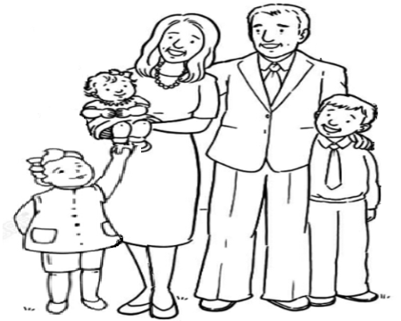Study the nuclear family below.**

**Roles of a brother**

* Helps parents in the housework

**Roles of sister**

* Helps mother with domestic work.
* Carries the baby.

**Roles of children**

* Children clean the home
* Children fetch water
* Children collect firewood
* Children wash utensils
* Children carry babies

**Roles of the mother**

* Cares for children
* Cooks food

**Roles of the father**

* Pays school fees and rent
* Provides basic needs at home
* Builds the house

**A home** is a place where people or animals live.

**Extended family**

An extended family is a type of family where we find grandfather, grandmother, aunt, mother, father, children and other family relatives of the family.

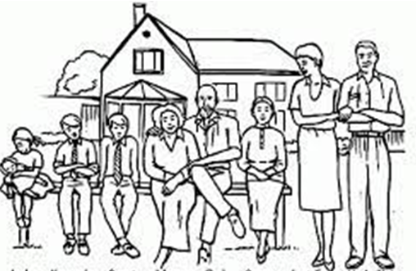Study the extended family below.

**Marriage** is the legal union of a man and a woman as husband and wife.

**Activities done at home**

* Cooking food
* Washing clothes
* Washing utensils
* Ironing clothes

**Activity**

1. What is a family?

2. Name three types of families.

i)

ii)

iii)

3. What is a home?

4. Define marriage.

5. What do we call people who are related?

6. Mention the people who start a family.

7. How many types of families do we have?

8. Define a nuclear family.

9. How important is a father to a family?

10. List down three people found in a nuclear family.

i)

ii)

iii)

11. Who heads a family?

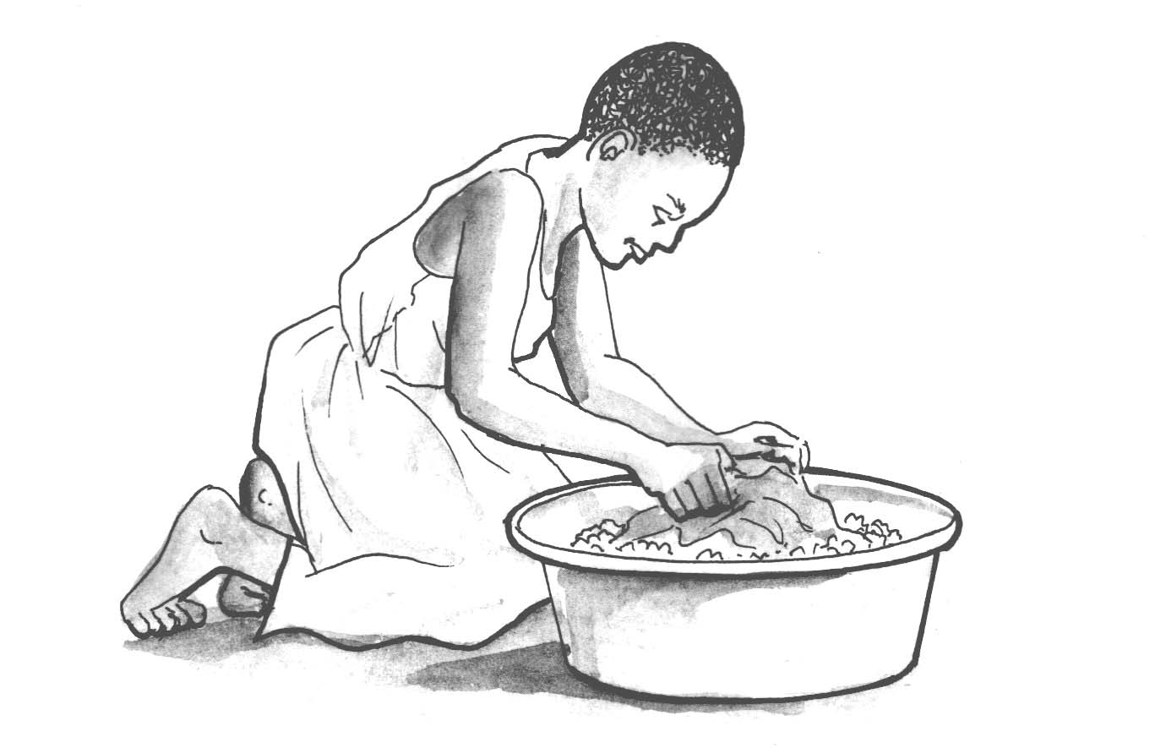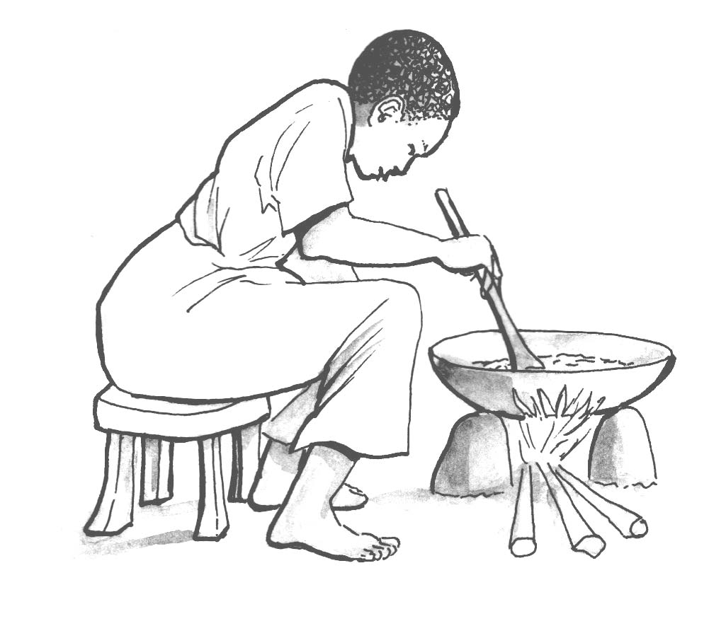12. Name these activities done by people at home

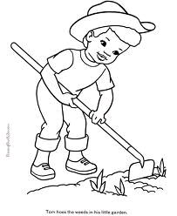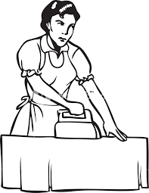

More practice (corrections)

***Score strip***

**** Checkup 3

Supervisor’s initial \_\_\_\_\_\_\_\_\_\_\_\_

Score \_\_\_\_\_\_\_\_\_\_\_\_

Supervisor’s comment \_\_\_\_\_\_\_\_\_\_\_\_\_\_\_\_\_\_\_\_\_\_\_\_

**PROJECT WORK**

Challenge!

**Word game**

family children nuclear

brother marriage father

sister extended mother

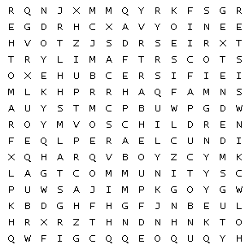trespassing foster community

|  |  |  |  |  |
| --- | --- | --- | --- | --- |
| **WEEK** | **VALUE PROMISE** | **MEMORY VERSE** | **CHARACTER TRAITS** | **WORK HABIT** |
| **FIVE** | “I will always do good to others the way I want them to do for me”. | Proverbs 31: 25 | 1. Be strong and of great dignity  2. Do not be fearful  3. Always work without ceasing  4. Rejoice in the lord and be thankful.  5. Be helpful | Believe you can and you’re halfway there |

Proverbs 31: 25 “She is strong and of dignity; she is not afraid of the future”.

Work habit

Name: \_\_\_\_\_\_\_\_\_\_\_\_\_\_\_\_\_\_\_\_\_\_\_\_\_\_\_\_\_\_\_\_\_\_\_\_\_\_\_\_\_

Date: \_\_\_\_\_\_\_\_\_\_\_\_\_\_\_\_\_\_\_\_\_\_\_\_\_\_\_\_\_\_\_\_\_\_\_\_\_\_\_\_\_\_

School: \_\_\_\_\_\_\_\_\_\_\_\_\_\_\_\_\_\_\_\_\_\_\_\_\_\_\_\_\_\_\_\_\_\_\_\_\_\_\_\_\_

Spellings Corrections

1. 1.

2. 2.

3. 3.

4. 4.

5. 5.

**Family members according to gender**

**Gender;** is the state of being male or female.

**Types of gender**

* Male
* Female

**Members of a family who are female**

* Mother
* Aunts
* Girls
* Niece
* Grandmother

**Members of a family who are male**

* Father
* Boys
* Uncles
* Nephew
* Grandfather

**Family relationship**

* The father to my father or mother is my **grandfather.**
* The mother to my father or mother is my **grandmother.**
* The brother to my mother or mother is my **uncle.**
* The sister to my father or mother is my **aunt.**
* The children of my uncle and aunt are my **cousins.**
* The son to my sister or brother is my **nephew.**
* The daughter to my sister or brother is my **niece.**

**Basic needs of a home**

These are things a person cannot do without.

**Examples of basic needs**

* Food
* Shelter
* Water
* Medical care
* Clothes

**Activity**

1. Who is the mother of your mother?

2. The man who produced your mother or father is your

3. What do you call the brother of your mother?

4. Who is the sister of your father?

5. What do you call the daughter of your aunt?

6. Who is a niece?

7. Who is a nephew?

8. What are basic needs?

9. How important is water to man?

10. Why do we put on clothes?

11. Why do people build houses and put on ventilators?

**12. Name these basic needs.**

MC900332928[1]BL00301_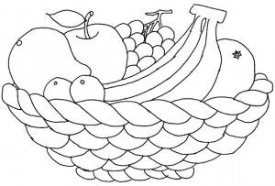



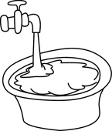

More practice (corrections)

***Score strip***

Name: \_\_\_\_\_\_\_\_\_\_\_\_\_\_\_\_\_\_\_\_\_\_\_\_\_\_\_\_\_\_\_\_\_\_\_\_\_\_\_\_\_

Date: \_\_\_\_\_\_\_\_\_\_\_\_\_\_\_\_\_\_\_\_\_\_\_\_\_\_\_\_\_\_\_\_\_\_\_\_\_\_\_\_\_\_

Spellings Corrections

1. 1.

2. 2.

3. 3.

4. 4.

5. 5.

**Community**

A community is a group of people living and working together.

People in our community

fishermen fishmongers doctors

carpenters builders barbers

police officers electricians shopkeepers

teachers farmers religious leaders

**Examples of community**

Police station

Home community

Mosque community

Market community

Church community

**Examples of roles played by different people in our community:**

|  |  |  |
| --- | --- | --- |
| **ANd9GcRha3iP-S4GccQzs2VwoHgvlcDFeMBaHWMOCiILzEgUAeNJxYx0**  doctor treats people | **MC900436129[1]**  teacher teaches pupils | **MC900310388[1]**  preacher preaches the word of God. |
| **C:\Users\lg\Pictures\Pictures\Proffessions\iuxhc1w.jpg**  mechanics repair our cars. | **F:\Denis\20190527_120400.jpg**  carpenter makes furniture. | farmer grows crops and keeps animals. |

**Activity**

1. What is a community?

2. Give examples of communities.

3. Name ten people who serve in the community.

i) vi)

ii) vii)

iii) viii)

iv) ix)

v) x)

4. Where do they work from?

teacher

policeman

carpenter

barber

doctor

5. Give out their roles in the community.

A butcher

A driver

A builder

A midwife

An optician

A cobbler

6. Write 2 places of worship.

i)

ii)

More practice (corrections)

***Score strip***

Name: \_\_\_\_\_\_\_\_\_\_\_\_\_\_\_\_\_\_\_\_\_\_\_\_\_\_\_\_\_\_\_\_\_\_\_\_\_\_\_\_\_

Date: \_\_\_\_\_\_\_\_\_\_\_\_\_\_\_\_\_\_\_\_\_\_\_\_\_\_\_\_\_\_\_\_\_\_\_\_\_\_\_\_\_\_

Spellings Corrections

1. 1.

2. 2.

3. 3.

4. 4.

5. 5.

**Activities done in a community and the tools they use.**

|  |  |  |
| --- | --- | --- |
| teaching | washing | craft making |
| sweeping | pottery | building |
| farming | fishing |  |

**People and their tools**

|  |  |  |
| --- | --- | --- |
| C:\Users\LG COMPUTERS\Desktop\New folder (3)\material\teacher chalk.jpg  A teacher with a piece of chalk. | C:\Users\LG COMPUTERS\Desktop\New folder (3)\material\grand mufti.png  Imam with a Quran. | A famer with a hoe. |

|  |  |  |  |  |  |
| --- | --- | --- | --- | --- | --- |
| C:\Users\LG COMPUTERS\Desktop\New folder (3)\material\pastor bible.png  A preacher with a bible. | | C:\Users\LG COMPUTERS\Desktop\New folder (3)\material\doctor syringe 2.jpg  A doctor with a syringe | | C:\Users\LG COMPUTERS\Desktop\New folder (3)\material\bulder.jpg  A builder with a wheelbarrow and spade. | |
| F:\Denis\20190527_120400.jpg  A carpenter with a sow | | | C:\Users\lg\Pictures\Pictures\Proffessions\iuxhc1w.jpg  A mechanic with spanners. | | |
| **C:\Users\LG COMPUTERS\Desktop\DEBORAH\optician.png** | | **C:\Users\LG COMPUTERS\Desktop\DEBORAH\oculist.png** | |
| Optician makes spectacles and sells them | | Oculist treats sick eyes | |

**Activity**

1. Name the tool these people use at their places of work

Reverend

Farmer

Photographer

Carpenter

2. Name any 3 common disease people suffer in your community.

i)

ii)

iii)

3. Give a reason why some people in your community are poor.

4. How can people prevent diseases in your community?

5. Give the problems faced by the people in your community.

i)

ii)

6. Mention the activities done in your community.

7. Give two types of house in your area.

i)

ii)

8. What are temporary houses?

9. Draw and name 3 examples of temporary houses.

|  |  |  |
| --- | --- | --- |
|  |  |  |
|  |  |  |

10. What are permanent houses?

11. Suggest the examples of permanent house.

i)

ii)

iii)

12. Identify 3 strong building materials.

i)

ii)

iii)

More practice (corrections)

***Score strip***

****

Checkup 4

Supervisor’s initial \_\_\_\_\_\_\_\_\_\_\_\_

Score \_\_\_\_\_\_\_\_\_\_\_\_

Supervisor’s comment \_\_\_\_\_\_\_\_\_\_\_\_\_\_\_\_\_\_\_\_\_\_\_\_

**PROJECT WORK**

Observe the different people in your community and write them down. Give their roles and importance to the community.

Write down the challenges/problems you would have faced if they were not in your community.

We should appreciate the roles of people in our society.

|  |  |  |  |  |
| --- | --- | --- | --- | --- |
| **WEEK** | **VALUE PROMISE** | **MEMORY VERSE** | **CHARACTER TRAITS** | **WORK HABIT** |
| **SEVEN** | “I choose to be at peace and have good team work”. | Psalm 127:3-5 | 1. Be responsible  2. Be God fearing  3. Be compassionate to your children  4. Be obedient & respect for children  5. Cherish the glory of your children | Discipline is the bridge between goals and accomplishment |

Psalm 127:3-5 “Children are a gift from the lord, they are a real blessing like arrows in the hands of a warrior, are children born in one’s youth”.

Work habit

Name: \_\_\_\_\_\_\_\_\_\_\_\_\_\_\_\_\_\_\_\_\_\_\_\_\_\_\_\_\_\_\_\_\_\_\_\_\_\_\_\_\_

Date: \_\_\_\_\_\_\_\_\_\_\_\_\_\_\_\_\_\_\_\_\_\_\_\_\_\_\_\_\_\_\_\_\_\_\_\_\_\_\_\_\_\_

School: \_\_\_\_\_\_\_\_\_\_\_\_\_\_\_\_\_\_\_\_\_\_\_\_\_\_\_\_\_\_\_\_\_\_\_\_\_\_\_\_\_

Spellings Corrections

1. 1.

2. 2.

3. 3.

4. 4.

5. 5.

**Culture -** is a common way of behaving in a society **or** Is the acceptable behavior in a given community.

**Tribe** is a group of people having the same origin and speaking the same language.

**Clan** is an organized group of people under the same ancestor or fore father.

**Cultural practices in our community.**

Dressing

Marriage

Greeting

Child naming

Dancing

Funeral rites

Eating,

Cooking,

Celebrating childbirth

Praying

Singing

Hunting

**Values**

Values are good morals.

**Examples of values**

- Respecting people.

- Greeting people.

- Showing love to others.

- Being responsible

**Examples of cultural practices**

|  |  |
| --- | --- |
| http://imageenvision.com/150/61827-clipart-of-a-retro-boy-kneeling-in-black-and-white---royalty-free-vector-illustration-by-jvpd.jpgD:\MY PHOTOZ\Luganda-BK1\woman sit on mat.jpg  Kneeling down to greet elders. | C:\Users\LG COMPUTERS\Desktop\New folder (3)\material\hugging.png  Hugging when greeting. |
| ANd9GcRA6AH-tV_ksMeDXUFtpOMZ9BbcfY4SFa1a9HRN0JnY3F8esv0zgg  Some people pray while kneeling. | C:\Users\LG COMPUTERS\Desktop\New folder (3)\material\muslim.jpg  Moslems pray while prostrating. |
| C:\Users\LG COMPUTERS\Desktop\DEBORAH\steaming.png  Some people cook food by steaming. | D:\MY PHOTOZ\Luganda-BK1\woman cooking-1.jpg  Some people mingle food. |
| C:\Users\LG COMPUTERS\Desktop\New folder (3)\material\church wedding.jpg  Some people get married in church. | C:\Users\LG COMPUTERS\Desktop\DEBORAH\customary marriage.jpg  Some people make customary marriages |

**Importance of culture**

- Culture brings people together

- Culture promotes love and unity

- Culture promotes good morals

**Ways of promoting culture.**

- Teaching people the culture

- Attending clan meeting

- Attending marriage ceremonies

**Activity**

1. What is culture?

2. Define a tribe.

3. Give any 4 examples of things which make up culture.

i)

ii)

iii)

iv)

4. What language do the following speak?

Bakiga

Baganda

Basoga

Banyankole

5. Define a clan

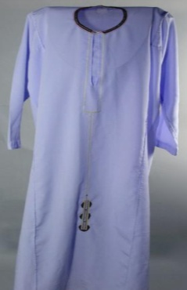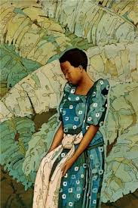6. Name these traditional wears of the Baganda.

7. What are values?

8. Give any 2 any examples of values.

i)

ii)

9. How important is culture to people in Uganda?

10. Give any two ways of promoting culture.

i)

ii)

11. Give any four cultural dances you know.

i)

ii)

iii)

iv)

12. Draw a picture of Muganda girl greeting the father.

More practice (corrections)

***Score strip***

Name: \_\_\_\_\_\_\_\_\_\_\_\_\_\_\_\_\_\_\_\_\_\_\_\_\_\_\_\_\_\_\_\_\_\_\_\_\_\_\_\_\_

Date: \_\_\_\_\_\_\_\_\_\_\_\_\_\_\_\_\_\_\_\_\_\_\_\_\_\_\_\_\_\_\_\_\_\_\_\_\_\_\_\_\_\_

Spellings Corrections

1. 1.

2. 2.

3. 3.

4. 4.

5. 5.

**THEME: HUMAN BODY AND HEALTH.**

**SUBTHEME: Parts of the body and their functions.**

**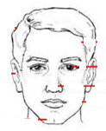1. Parts of the head.**

hair

eye

nose

mouth

 chin

**2. Parts of arm.**

fingers shoulder

fingernail

hand elbow

**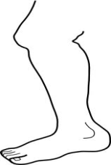3. Parts of the leg.**

knee toes

foot

thigh ankle

**4. Parts of the body.**

Below is the human body with its parts.

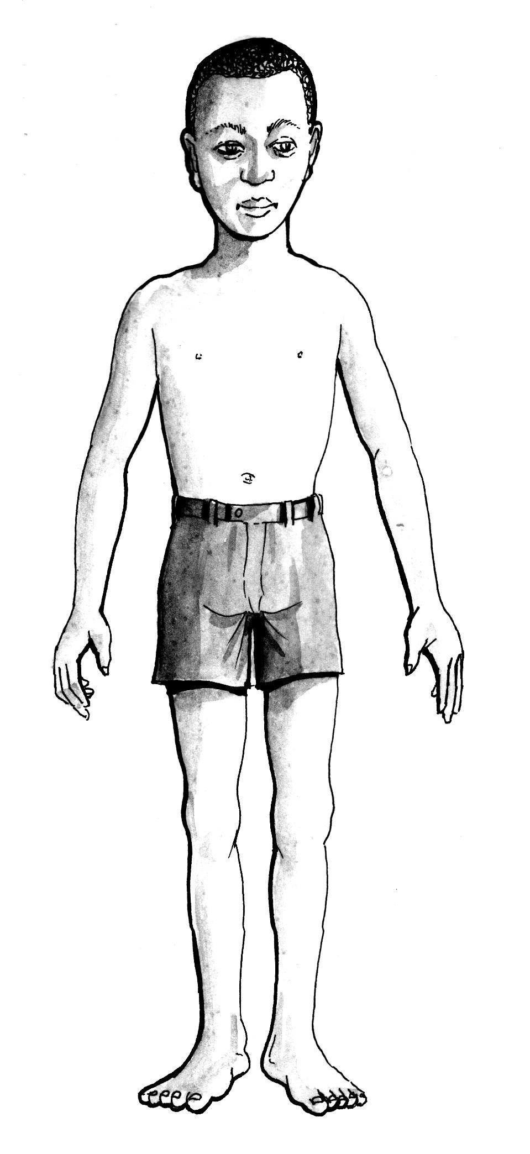 hair eyelid

eye ear

nose mouth

elbow

chest stomach

hand

leg knee

toe foot

**Activity**

1. How many eyes do you have?

2. How many ears do you have?

3. Name at least five internal parts of the body.

i)

ii)

iii)

iv)

v)

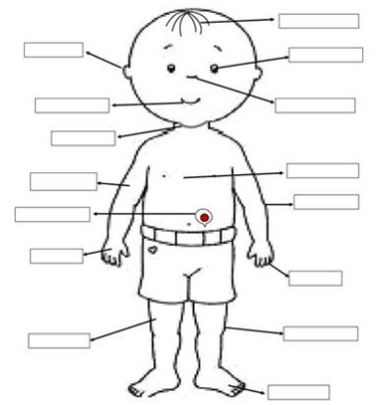4. Name the parts of the body in the boxes.

5. Write any three parts of the body which are in pairs.

i)

ii)

iii)

6. Which part of body holds the head?

7. Name the part of the body that covers the flesh.

8. Name the parts of the arm.

iii i

i ii

ii iii

Corrections

***Score strip***

Name: \_\_\_\_\_\_\_\_\_\_\_\_\_\_\_\_\_\_\_\_\_\_\_\_\_\_\_\_\_\_\_\_\_\_\_\_\_\_\_\_\_

Date: \_\_\_\_\_\_\_\_\_\_\_\_\_\_\_\_\_\_\_\_\_\_\_\_\_\_\_\_\_\_\_\_\_\_\_\_\_\_\_\_\_\_

Spellings Corrections

1. 1.

2. 2.

3. 3.

4. 4.

5. 5.

**Sense organs**

|  |  |  |
| --- | --- | --- |
| http://t1.gstatic.com/images?q=tbn:ANd9GcRF_jcvQ35HuMRybPkxHR6K4UGpJPRKXzpF7TbbcturOS4QGbvJWw  seeing | http://t0.gstatic.com/images?q=tbn:ANd9GcSD1Kf75_9-tXlzFCNqJma0wgQ7wzB-ST1xQkabDoMGCWn8N_2l  smelling | ear.jpg  hearing |
| Description: C:\Documents and Settings\esther\Local Settings\Temporary Internet Files\Content.IE5\CHC84USA\MP900448668[1].jpg  tasting | We use the skin for feeling  feeling |

**Activity**

1. Give the use of the following body pats.

Mouth is used for

Legs are used for

2. Mention any four sense organs of the body.

i)

ii)

iii)

iv)

3. What do you use to touch?

4. Match the following.

|  |  |
| --- | --- |
| Sense organ | Senses |
| eyes | smelling |
| ears | feeling |
| nose | seeing |
| tongue | hearing |
| skin | testing |

5. Which part of the body do you use to;

a) Breathe

b) Pick something

c) Kick a ball

d) Read

More practice (corrections)

***Score strip***

Name: \_\_\_\_\_\_\_\_\_\_\_\_\_\_\_\_\_\_\_\_\_\_\_\_\_\_\_\_\_\_\_\_\_\_\_\_\_\_\_\_\_

Date: \_\_\_\_\_\_\_\_\_\_\_\_\_\_\_\_\_\_\_\_\_\_\_\_\_\_\_\_\_\_\_\_\_\_\_\_\_\_\_\_\_\_

Spellings Corrections

1. 1.

2. 2.

3. 3.

4. 4.

5. 5.

**Personal hygiene**

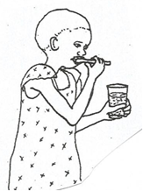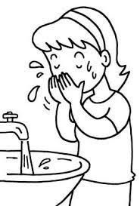MC900310258[1]Is the general cleanliness of our bodies and things we use.

|  |  |  |
| --- | --- | --- |
| bathing | brushing teeth | C:\Users\LG COMPUTERS\Desktop\PICTURES AND ACTIVITIES\JAN 2020\FORMER\Former Dowloads\class rules\man-ironing-retro-clipart-illustration-MFM480.jpgwashing face |
| https://media.ldscdn.org/images/media-library/primary/primary-symbols/nursery-manual-symbols/girl-brushing-hair-whittaker-387240-gallery.jpg  combing hair | C:\Users\LG COMPUTERS\Desktop\New folder (3)\fingernails.jpg  cutting fingernails | ironing clothes |
| https://s-media-cache-ak0.pinimg.com/736x/a2/6a/e2/a26ae2153885c5cc7ff24c9812f1436a.jpg  trimming hair | ANd9GcSes3sslJi1P8Adg170PCK6nx6ECki5Lw8uGuaZ5XEItFRymaLwwQ  washing clothes |

**Things used to clean the body**

The things used to clean the body are:

|  |  |  |  |
| --- | --- | --- | --- |
| water | Image result for toothbrush images clip art  toothbrush | razor blade | Related image  comb |
| D:\MY PHOTOZ\Luganda-BK1\Basin.jpg  basin | C:\Users\user\Desktop\New folder\scan0004.jpg  towel | C:\Users\lg\Pictures\Screenshot_2019-01-29-18-18-44.jpg  nail cutter | Description: C:\Documents and Settings\esther\Local Settings\Temporary Internet Files\Content.IE5\CHC84USA\MC900371132[1].wmf  scrubbing brush |
| stock-photo-natural-round-textile-bath-sponge-isolated-on-white-62949280  sponge | stone | soap  soap | Description: C:\Documents and Settings\esther\Local Settings\Temporary Internet Files\Content.IE5\XS5NRJF0\MC900371086[1].wmf  tooth paste |

**Ways of maintaining personal hygiene**

* Bathing regularly
* Washing clothes
* Washing hands after visiting the toilet/latrine
* Combing and trimming our hair
* Brushing after every meal

**Reasons why we keep/maintain personal hygiene**

* We brush our teeth to prevent cavities.
* We brush our teeth to prevent tooth decay.
* We brush our teeth to prevent bad breath.
* We bathe to avoid body odor.
* We bathe to remove dirt from the body.
* We bathe to prevent germs.
* We wash our hand to remove germs.
* We cut our fingernails short to destroy the breeding places for germs.
* We boil water for drinking to kill germs.

**Activity**

1. What is personal hygiene?

2. Name the activities of keeping personal hygiene below.

|  |  |  |
| --- | --- | --- |
| MC900310258[1] |  | C:\Users\LG COMPUTERS\Downloads\WASHING FACE.jpg |

3. Name any three good health habits.

i)

ii)

iii)

4. Draw and name five things used to keep the body clean.

|  |  |  |  |  |
| --- | --- | --- | --- | --- |
|  |  |  |  |  |
|  |  |  |  |  |

5. Mention three reasons for keeping personal hygiene.

i)

ii)

iii)

6. Match the following body parts to their ways of keeping them clean.

|  |  |
| --- | --- |
| Teeth | keeping the short |
| Body | brush |
| Hair | combing |
| Finger nails | bathing |

7. Why do we bathe?

8. Why do we brush our teeth?

9. Name the two things we use to brush our teeth

i)

ii)

10. Give two ways of keeping our clothes clean.

i)

ii)

11. Why should drinking water be boiled?

12. Why do we wash our hands?

More practice (corrections)

***Score strip***

****

Checkup 5

Supervisor’s initial \_\_\_\_\_\_\_\_\_\_\_\_

Score \_\_\_\_\_\_\_\_\_\_\_\_

Supervisor’s comment \_\_\_\_\_\_\_\_\_\_\_\_\_\_\_\_\_\_\_\_\_\_\_\_

**PROJECT WORK**

Find out more about your culture from your elders. Write down at least 10 cultural practices carried out in your culture.

|  |  |  |  |  |
| --- | --- | --- | --- | --- |
| **WEEK** | **VALUE PROMISE** | **MEMORY VERSE** | **CHARACTER TRAITS** | **WORK HABIT** |
| **EIGHT** | “I believe God will always help me to be a good leader”. | Mathew 20 : 27 -28 | 1. Be a good leader  2. Do not be judgmental  3. Be kind and patient  4. Seeks God’s approval always  5. Be responsible | Discipline is what you must have to resist the lies of excuses |

Mathew 20 : 27 -28 “And whoever would be first among you must be your slave, even as the son of man came not to be served but to serve and to give life as a ransom for many”.

Work habit

Name: \_\_\_\_\_\_\_\_\_\_\_\_\_\_\_\_\_\_\_\_\_\_\_\_\_\_\_\_\_\_\_\_\_\_\_\_\_\_\_\_\_

Date: \_\_\_\_\_\_\_\_\_\_\_\_\_\_\_\_\_\_\_\_\_\_\_\_\_\_\_\_\_\_\_\_\_\_\_\_\_\_\_\_\_\_

Spellings Corrections

1. 1.

2. 2.

3. 3.

4. 4.

5. 5.

**IMMUNISATION**

**Immunization** is the introduction of a vaccine in to the body.

**Examples of immunisable disease**

Polio, hepatitis B, tuberculosis, whooping cough, measles, diphtheria

**Importance of immunisation**

- To promote body immunity.

- To avoid spreading diseases.

- To avoid sickness.

**Common diseases**

Disease is an illness affecting humans, animals or plants, often caused by infections.

Illness: This is a persistent body disorder or disease.

**Examples of common diseases**

|  |  |
| --- | --- |
| cough | chicken pox |
| skin rash | ringworms |
| dysentery | flu |
| malaria  Typhoid | Mumps  Measles |

**Ways of preventing and controlling diseases**

* We wash hands before eating food.
* We should spit anywhere
* We should drain away stagnant water
* We should use the latrines well
* We should sleep under well treated mosquito nets
* We spray using insecticides
* We should guard against insects

**Activity**

1. List at least six common diseases you know.

i) iv)

ii) v)

iii) vi)

2. Write two ways of how we can control malaria?

i)

ii)

3. Which medicine is used to immunise people?

4. What is the importance of immunisation?

5. What is immunisation?

6. Write down any three immunisable diseases.

i)

ii)

iii)

7. Name the diseases immunized through the site show.

Mouth

Right upper arm

Left upper arm

Left thigh

8. Draw a child with measles.

More practice (corrections)

***Score strip***

Name: \_\_\_\_\_\_\_\_\_\_\_\_\_\_\_\_\_\_\_\_\_\_\_\_\_\_\_\_\_\_\_\_\_\_\_\_\_\_\_\_\_

Date: \_\_\_\_\_\_\_\_\_\_\_\_\_\_\_\_\_\_\_\_\_\_\_\_\_\_\_\_\_\_\_\_\_\_\_\_\_\_\_\_\_\_

Spellings Corrections

1. 1.

2. 2.

3. 3.

4. 4.

5. 5.

**SANITATION**

Sanitation is the general cleanliness of the environment.

**Places that need to be kept clean at home.**

Bathroom

Toilet

Kitchen

Bedroom etc

**How to keep our compound clean**

- By sweeping.

- By slashing the compound.

- By mopping the house.

**Why do we clean our compound?**

- To prevent diseases caused by their agents.

- To prevent bad smell.

**Material/ things used to keep places clean.**

|  |  |  |  |
| --- | --- | --- | --- |
| water | 427615  slasher | Description: C:\Documents and Settings\esther\Local Settings\Temporary Internet Files\Content.IE5\CHC84USA\MC900371132[1].wmf  brush | Related image  soap |
| 461766963  hoe | broom | C:\Documents and Settings\esther\Local Settings\Temporary Internet Files\Content.IE5\30TEQDAG\MC900340376[2].wmf  rake | dglxasset[1]  panga |
| C:\Users\LG COMPUTERS\Desktop\New folder (3)\pics\mop.jpg  rag | ANd9GcQ8mzG6fE8OZ1FDIPQWxevOth8zuvIG9kQePnhQODTsNh3qrIr2  shear |  |

**Activity**

1. What is sanitation?

2. How can we keep the compound clean?

3. Draw these things used to clean the compound.

|  |  |  |  |
| --- | --- | --- | --- |
|  |  |  |  |
| slasher | broom | hoe | rake |

4. How can we keep our classrooms clean?

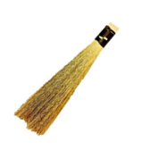5. Write the uses of the following tools.

|  |
| --- |
|  |

|  |
| --- |
|  |
| D:\MY PHOTOZ\Luganda-BK1\Slash.jpg |

6. People who help us to keep the compound clean are called

7. Name four types of work you do at home.

i)

ii)

iii)

iv)

8. Why should we clean the compound?

More practice (corrections)

***Score strip***

Name: \_\_\_\_\_\_\_\_\_\_\_\_\_\_\_\_\_\_\_\_\_\_\_\_\_\_\_\_\_\_\_\_\_\_\_\_\_\_\_\_\_

Date: \_\_\_\_\_\_\_\_\_\_\_\_\_\_\_\_\_\_\_\_\_\_\_\_\_\_\_\_\_\_\_\_\_\_\_\_\_\_\_\_\_\_

Spellings Corrections

1. 1.

2. 2.

3. 3.

4. 4.

5. 5.

**THEME: FOOD AND NUTRITION.**

**SUB THEME CLASSIFTCATION OF FOOD**

1. **Food**

Food is something good to eat or drink.

Classes of food

Carbohydrates

Proteins

Vitamins

**Classes of food**

**Carbohydrates;** are energy giving foods. They include;

Cassava, yams, posho, rice, bread, wheat, sorghum, millet, sweet potatoes and more

**Proteins;** are body building foods. They include; eggs, milk, bread, meat, beans, fish and more.

**Vitamins;** are protective / healthy foods. They include; vegetable like cabbage, nakati, dodo, tomatoes, carrots, onions and fruits like oranges, apples, pineapples, pawpaw, banana, watermelon, mango and more.

**Fats;** are foods that make our bodies grow big / fat. They include; cheese, mayonnaise, ghee, bongo, meat, and more.

**Activity**

1. What is food?

2. Write any three classes of food.

i)

ii)

iii)

3. Which name is given to the body building food?

4. What are proteins?

5. Identify at least five examples of carbohydrates.

i)

ii)

iii)

iv)

v)

6. Which name is given to the healthy giving foods or protective foods?

7. Draw the fruits.

|  |  |  |
| --- | --- | --- |
| mangoes | oranges | pineapple |
|  |  |  |
| banana | watermelon |
|  |  |

8. Give at least six examples of vegetables.

i)

ii)

iii)

iv)

v)

vi)

More practice (corrections)

***Score strip***

Name: \_\_\_\_\_\_\_\_\_\_\_\_\_\_\_\_\_\_\_\_\_\_\_\_\_\_\_\_\_\_\_\_\_\_\_\_\_\_\_\_\_

Date: \_\_\_\_\_\_\_\_\_\_\_\_\_\_\_\_\_\_\_\_\_\_\_\_\_\_\_\_\_\_\_\_\_\_\_\_\_\_\_\_\_\_

Spellings Corrections

1. 1.

2. 2.

3. 3.

4. 4.

5. 5.

**Sources of food**

**A source of food** is a place where food comes from or originates from.

**Sources of food**

Plants, Animals, Water

**Activity**

1. Name one source of food.

2. Mention any three places where we can get food from.

i)

ii)

iii)

3. Outline any six examples of food got from the garden.

i) iv)

ii) v)

iii) vi)

4. Under which class of food are eggs and chicken?

5. Why do we eat food?

6. Match animals to their meat.

|  |  |
| --- | --- |
| pig | chicken |
| sheep | fish fillet |
| rabbit | pork |
| fish | beef |
| hen | mutton |
| cow | rabbit pie |

7. Which food do we get from lakes and rivers?

8. Name any three examples of food we get from factories.

i)

ii)

iii)

9. Name the market near your school.

10. Name the food got from the garden.

|  |  |
| --- | --- |
| https://encrypted-tbn0.gstatic.com/images?q=tbn:ANd9GcQlDHHQ2Z8uLyF7MoVYEM5TkYVTT8RA5ok2BQcMiO1uGQbkhjwO |  |

11. Identify any five examples of drinks.

i) iv)

ii) v)

iii)

12. Draw a market and show people selling and buying food.

More practice (corrections)

***Score strip***

****

Checkup 6

Supervisor’s initial \_\_\_\_\_\_\_\_\_\_\_\_

Score \_\_\_\_\_\_\_\_\_\_\_\_

Supervisor’s comment \_\_\_\_\_\_\_\_\_\_\_\_\_\_\_\_\_\_\_\_\_\_\_\_

**PROJECT WORK**

Sanitation is very important in our lives. It is therefore important to keep hygiene of our surroundings.

In your groups, make a daily rota together with your classmates on different sanitation duties such as sweeping the class, cleaning your offices, mopping and many more. Do

this with the help of your supervisors.

|  |  |  |  |  |
| --- | --- | --- | --- | --- |
| **WEEK** | **VALUE PROMISE** | **MEMORY VERSE** | **CHARACTER TRAITS** | **WORK HABIT** |
| **NINE** | “I believe God will always help me to be devoted”. | John 3 : 16 | 1. Be so loving  2. Be prayerful and alert  3. Fear God as your teacher  4. Honor one another  5. Be faithful. | Excellence is not a skill. It’s an attitude |

John 3:16 “For God so loved the world that he gave his only begotten son, that whoever believers in him shall not perish but have eternal life”.

Work habit

Name: \_\_\_\_\_\_\_\_\_\_\_\_\_\_\_\_\_\_\_\_\_\_\_\_\_\_\_\_\_\_\_\_\_\_\_\_\_\_\_\_\_

Date: \_\_\_\_\_\_\_\_\_\_\_\_\_\_\_\_\_\_\_\_\_\_\_\_\_\_\_\_\_\_\_\_\_\_\_\_\_\_\_\_\_\_

School: \_\_\_\_\_\_\_\_\_\_\_\_\_\_\_\_\_\_\_\_\_\_\_\_\_\_\_\_\_\_\_\_\_\_\_\_\_\_\_\_\_

Spellings Corrections

1. 1.

2. 2.

3. 3.

4. 4.

5. 5.

**Good feeding is having a balanced diet.**

A balanced diet is a meal which contains all food values in their correct amount.

**Ways of preserving food.**

- By salting

- By smoking

- By tinning

- By sun drying

- By refrigerating

**Things used to store food.**

- Tins

- Fridge

- Granary

- Basket

- Shelf / rack

**Examples of meals containing a balanced diet**

|  |  |  |  |
| --- | --- | --- | --- |
| Meal | Energy giving food | Body building food | Protective food |
| Breakfast | Bread | Milk | Yellow  banana |
| Break snack | Chapatti | Egg | Orange |
| Lunch | posho + matooke | Beans | Cabbages + pawpaw |
| Supper | Rice + matooke | Peas + fish | Ddodo  (amaranthas) |

**Activity**

1. How can food be preserved?

i)

ii)

iii)

iv)

2. Which food can be preserved by smoking food?

3. How can we keep seeds for a long time?

4. Name these things used to store food safely.

|  |  |
| --- | --- |
| https://encrypted-tbn3.gstatic.com/images?q=tbn:ANd9GcQ0Mb1TqUDGBjLdMJG16jO-YFZU3bGN2XHQX8g4SCdOgENg4sci | Big-Basket |
| C:\Users\LG COMPUTERS\Desktop\New folder (3)\material\fridge.png | C:\Users\LG COMPUTERS\Desktop\New folder (3)\material\cupboatd.png |

***Score strip***

**MALNUTRITION**

Malnutrition is when someone becomes ill or weak due to poor feeding.

**Examples of malnutritional diseases**

Beriberi

Goiter

Rickets

Scurvy

Night blindness

**Diseases and their causes**

Beriberi is caused by lack of vitamin B1.

Goiter is caused by lack of iodine

Rickets is caused by lack of vitamin A

Scurvy is caused by lack of vitamin C

Night blindness is caused by lack of vitamin A

|  |  |
| --- | --- |
| **Kwashiorkor**  Kwashiorkor is caused by lack of body building food in the body.  (proteins)  **C:\Users\LG COMPUTERS\Desktop\New folder (3)\material\kwashiorkor.jpg** | **Marasmus**  Marasmus is caused by lack of energy giving food in the body.+  C:\Users\LG COMPUTERS\Desktop\New folder (3)\material\marasmus.png(Carbohydrates) |

**Effects of poor feeding**

- Malnutrition.

- Poor body shape.

- Death.

- Blindness.

- Poor body health.

**Signs of poor feeding**

- Loss of weight.

- Swollen body.

- Change in hair colour (brownish)

- Loss of appetite.

- Dullness.

- Obesity (gaining too much weight)

**Activity**

1. is a condition when one is weak

or ill due to poor feeding.

2. Give any four effects of poor feeding.

i)

ii)

iii)

iv)

3. Mention any four signs of poor feeding.

i)

ii)

iii)

iv)

More practice (corrections)

***Score strip***

****

Checkup 7

Supervisor’s initial \_\_\_\_\_\_\_\_\_\_\_\_

Score \_\_\_\_\_\_\_\_\_\_\_\_

Supervisor’s comment \_\_\_\_\_\_\_\_\_\_\_\_\_\_\_\_\_\_\_\_\_\_\_\_

**PROJECT WORK**

Record your daily meals at home. Group them and identify whether it is a balanced diet or not. If it is not a balanced diet, advise your parents on the best way to make it better.